WC Squads (world_cup_2018_squads)

The dataset contains the details of Football (Soccer) players, which contain the column like Type, Team, Group, Position, Name, DOB, Caps, Goals & Country and club.

1. Country Vs Goals

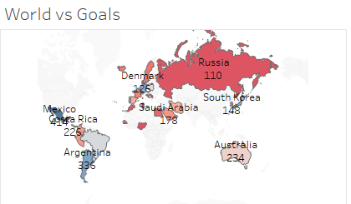

The above Sheet represents the sum of Goals(aggregated by the country level) scored by the players.

1. Players Vs Goals scored based on their country

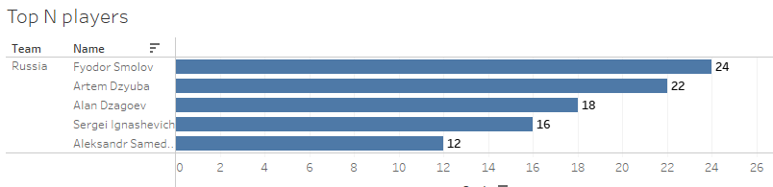

The above sheet contains the sum of goals scored by top N players (aggregated on players goal scored level) respective to their country.

3. Country and club Vs Players

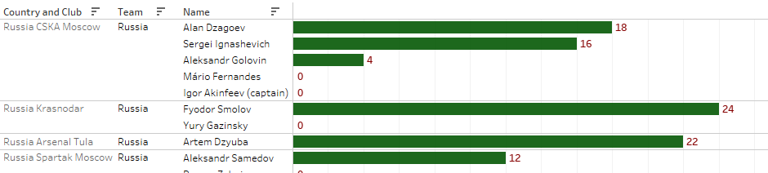

The above sheet contains the players who scores sum of goals (aggregated based on player goal scored level) in the respective Country and club based on their country which they belong to.

4. Players Vs Age group

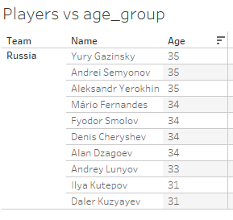

The above sheet contains the tabular data of the players based on their age group respective to the country they belong to.